

**Tribhuvan University**

**Faculty of Humanities and Social Science**

**WATER-BILLING MANAGEMENT SYSTEM (WBILL)**

**A PROJECT REPORT**

**Submitted to**

Department of Computer Application

Itahari Namuna College

*In partial fulfillment of the requirements for the degree of Bachelor’s in computer application.*

**Submitted By**

Priyanshu Sharma

Niraj Shrestha

**Under the Supervision of**

Er. Chandra Prasad Acharya



**Tribhuvan University**



**Faculty of Humanities and Social Sciences Itahari Namuna College**

# Supervisor’s Recommendation

I hereby recommend that this project prepared under my supervision

By the group (Priyanshu Sharma and Niraj Shrestha) entitled The

**“WATER BILLING MANAGEMEN SYSTEM” (WBILL)** in partial fulfilment of the requirements for the degree of bachelor’s in computer application are recommended for the final evaluation.

Er. Chandra Prasad Acharya

Project Supervisor

Itahari Namuna College

Itahari-8, Sunsari



**Tribhuvan University**



**Faculty of Humanities and Social Sciences Itahari Namuna College**

**Letter of Approval**

This is to certify that this project prepared by Priyanshu Sharma and Niraj Shrestha entitled **“Water-Billing Management System”** in partial fulfilment of the requirements for the degree of bachelor’s in computer application has been evaluated. In our opinion it is satisfactory in the scope and quality as a project for the required degree.

Chandra prasad acharya

Supervisor

Itahari Namuna College

Internal Examiner

Itahari Namuna College

Nabin Shrestha

HOD/Coordinator

Itahari Namuna College

External Examiner

Tribhuvan University

# Acknowledgement

The success and final outcomes of this project require a lot of guidance and assistance from many people and are very fortunate to have this all through the completion of this project. We would like to express our gratitude and appreciation to all those who gave us the possibility to complete this project. We are very glad to express our deepest sense of gratitude and sincere thanks to our supervisor Er. Chandra Prasad Acharya and project teacher Mr. Saroj Ojha whose contribution in simulating suggestions and encouragement helped us in completing our project.

We are also thankful to Mr. Nabin Shrestha, HOD, Itahari Namuna College and Mr.

Dharma Neupane, Principal, Itahari Namuna College for encouraging and guiding us throughout the completion of this project. All useful suggestions for this whole work and co-operative behaviour are sincerely acknowledged.

Last but not the least, many thanks go to our teachers, friends, guardians who directly or

indirectly helped us in achieving the goal. We would like to appreciate all the guidance and support which helped in the completion of this project. Special thanks to their comment and advice.

# Abstract

The water billing management system is a comprehensive software solution designed to streamline and enhance various aspects of water billing and management. It provides a centralized platform that facilitates efficient management of water billing-related activities, such as bill generation, payment processing, user interactions, and administrative tasks. The abstract of the water billing management system can be summarized as follows:

The water billing management system aims to improve the overall operational efficiency and customer experience in the water utility sector. It incorporates various modules and functionalities to automate and simplify different processes involved in water billing management.

Overall, the water billing management system aims to streamline operations, enhance customer satisfaction, and ensure accurate billing in the dynamic and essential water utility industry. Moreover It generates Final Bill With All the Details Allocated. By automating processes, centralizing data, and providing valuable insights, the system empowers water utility businesses to deliver exceptional services and achieve operational excellence. [Water billing management system, Water utility sector, Automation, Operational efficiency]

Top of Form

table of contents

Supervisor’s Recommendation ii

Acknowledgement iv

Abstract v

Chapter 1: Introduction 11

1.1 Introduction 11

1.2 Problem Statement 11

1.3 Objectives 11

1.4 Scope and Limitations 12

1.4.1 Scope 12

1.4.2 Limitation 12

1.5 Report Organization 13

1.6 Assignment of Roles and Responsibilities 14

Chapter 2: Literature Review 15

2.1 Background Study 15

2.2 Literature Review 15

Chapter 3: System Analysis and Design 17

3.1 System Analysis 17

3.1.1 Requirement Analysis 18

3.1.2 Feasibility Analysis 20

3.1.3 Data Modelling (ER Diagram) 22

3.1.4 Process Modelling (DFD) 23

3.2 System Design 27

3.2.1 Architectural Design 27

3.2.2 Database Schema Design 28

3.2.3 Interface Design 29

3.2.4 Software Design 33

Chapter 4: Implementation and Testing 37

4.1 Implementation 37

4.1.1 Tools Used 37

4.1.2 Implementation Details of Modules 38

4.2 Testing 38

4.2.1 Test Cases for Unit Testing 39

4.2.1 Test Cases for System Testing 41

Chapter 5: Conclusion and Future work 42

5.1 Lesson Learnt / Outcome 42

5.2 Conclusion 42

5.3 Future Recommendations 42

References 43

Appendices 44

Appendix 1: Screenshots 44

Appendix 2: Source Codes 47

Appendix 3: Database Table 54

**List of Figures**

Figure 3.1: Waterfall model 17

Figure 3.2: Use case digram 19

Figure 3.3: Gantt chart 21

Figure 3.4: ER Digram 22

Figure 3.5: Context Diagram 23

Figure 3.6: Level 1 DFD 24

Figure 3.7.1: Admin Level 2 DFD 25

Figure 3.7.2: Meter Reader Level 2 DFD 25

Figure 3.7.3: User Level 2 DFD 25

Figure 3.8: Architectural Diagram 27

Figure 3.9: Database Schema 28

Figure 3.10.1: Login Page Design 29

Figure 3.10.2: Admin Home Page Design 29

Figure 3.10.3: Meter Reader Home Page Design 20

Figure 3.10.4: User Registration Page Design 20

Figure 3.10.5: User Detail Page Design 21

Figure 3.10.6: Meter Reader Detail Page Design 21

Figure 3.10.7: bill view Detail Page Design 22

Figure 3.10.8: complain Page Design 22

Figure 3.11.1: Login Sequence diagram 33

Figure 3.11.2: Admin Sequence diagram 24

Figure 3.11.3: Meter Reader Sequence diagram 24

Figure 3.11.4: User Sequence diagram 25

Figure 3.12: Activity diagram 36

**List of Tables**

**Test Case Table**

Test Cases Table 1………………………………………………………………………29

Test Cases Table 2………………………………………………………………………31

**Database Table**

Table 1: User …………………………………………………………………………….43

Table 2: Packages………………………………………………………………………...43

Table 3: booking ….……………………………………………………………...............43

Table 4: booked ……………………………………………………………………….....43

Table 5: Review ………………………………………………………………………….43

**List of Abbreviations**

**CSS:** Cascading Style Sheets

**DFD:** Data Flow Diagram

**ER:** Entity Relationship

**HTML:** HyperText Markup Language

**IDE:** Integrate Development Environment

**JS:** JavaScript

**TC Id:** Test Case Id

**UI:** User Interface

# Chapter 1: Introduction

## 1.1 Introduction

Wbill is a water billing management system designed to serve as your go-to platform for all your water billing needs. Our system offers a centralized hub for managing water bills, user accounts, and complaints. Whether you're a customer looking to track your water usage, make payments conveniently through Khalti app, or report an issue, Wbill has you covered. With its intuitive interface and robust features, Wbill simplifies the process of water billing management, ensuring a hassle-free experience for both users and administrators. Trust Wbill to be your ultimate water billing companion and let us help you manage your water billing needs effortlessly.

## 1.2 Problem Statement

• **Billing and Reservation Challenges in Water Management**:

1. Double billing occurrences pose a significant challenge for water utility systems, leading to customer dissatisfaction and financial losses.
2. Inaccurate availability information regarding water resources can create confusion and frustration among consumers.
3. Difficulties in modifying or canceling water service requests can result in inconvenience for users and affect the utility's reputation.

* **Lack of Centralized Information in Water Billing:**

1. The absence of centralized information in water billing systems contributes to inefficiencies in accessing and updating consumer-related data.
2. This decentralized approach leads to delays in providing accurate information to consumers, impacting their experience with the water utility service.

* **Inventory Management Deficiencies in Water Utility Systems:**

1. Effective inventory management is crucial for water utility businesses to ensure optimal resource allocation and billing accuracy.
2. However, many water billing systems lack robust inventory management features.
3. Challenges such as overbilling, underutilization of water resources, and difficulty in managing meter readings arise due to the absence of comprehensive inventory management tools in water utility systems like Wbill.

## 1.3 Objectives

There are some objectives of this project:

* To offer a comprehensive database of destinations, activities, and accommodation options, providing travelers with reliable and relevant information to make informed decisions.
* To create an efficient and streamlined booking process that saves travelers time and reduces the risk of errors or mistakes.
* To promote sustainable tourism practices by offering eco-friendly options and educating travelers on sustainable tourism practices.
* To enhance the overall travel experience by providing personalized itineraries, recommendations, and social features to connect with other travelers and share experiences.

## 1.4 Scope and Limitations

### 1.4.1 Scope

This web-based application is designed to modernize and automate the management of water billing processes, eliminating the need for manual handling and paperwork.

* **Admin Panel:**

1. **Add User:** Admin can add users to the system.
2. **View Transactions:** Admin can view all transactions made by users.
3. **View Complaints:** Admin can view complaints submitted by users.
4. **Manage Users:** Admin can manage user accounts.
5. **Manage Meter Readers:** Admin can manage meter reader accounts.
6. **Approve Payments:** Admin can approve payments made by users.

* **Meter Reader Panel:**

1. **Read Meter:** Meter reader can enter meter readings for users.
2. **View Meter Readings:** Meter reader can view meter readings entered.

* **User Panel:**

1. **View Transactions:** Users can view their transaction history.
2. **Submit Complaints:** Users can submit complaints.
3. **Make Payments:** Users can make payments for their water bills.
4. **View Meter Readings:** Users can view meter readings entered by meter readers.
5. **View Due Amount:** Users can view their due amount.

* **Advantages of the Proposed System:**

1. **User-Friendly Interface:** Easy to use for all types of users.
2. **Fast Access to Database:** Quick retrieval and storage of data.
3. **More Storage Capacity:** Sufficient storage for storing user data.
4. **Search Facility:** Users can search for specific transactions .

**1.4.2 Limitations**

1. **Demo Version Only:** This version is intended for demonstration purposes and cannot be directly implemented in the real world.
2. **Internet Connection Required:** The system requires an internet connection to function.

## 1.5 Report Organization

The report consists of five chapters in which all the phased of application design and

development will be covered.

Chapter 1: The chapter introduces the system and the problems, gives an overview

about the study.

Chapter 2: The second chapter covers background study and the literature review of the

project.

Chapter 3: The third chapter covers the system analysis and design phase of the

application. It explains the methodology used while developing the system.

Chapter 4: The fourth chapter discuss about the implementation and testing phase of

the application development.

Chapter 5: The last chapter that is the fifth chapter covers the conclusion,

recommendations, and future works to improve this project.

## 1.6 Assignment of Roles and Responsibilities

Brief profiles of each team member and their general duties follow below. Many of the

responsibilities will be shared among team members to ensure the overall success of the project.

**-** **Niraj Shrestha** will be involved in interactions with the users for requirement determinations. He will help with the physical design of pages and contents. He will also help with coding and testing of the system. He will collect the facts and figures required for improvement of the system. He will implement the database into a program using programming languages and also helps in designing a user interface.

**-** **Priyanshu Sharma** will be also be involved in writing codes as well as works on

Analyses of the requirements, facts and figures collected by his team member and implements them in the system. He will design the required prototypes of the system. He will also implement the database into a program using programming languages. He plays the main role while designing a user interface.

Both members may work on the same files/tasks at the same time.

# Chapter 2: Literature Review

## 2.1 Background Study

## The Water Billing Management System (wbill) is designed to modernize and optimize the management of water consumption and billing processes. With a primary focus on providing users with a robust tool for handling their water usage and billing needs, wbill ensures a seamless experience from start to finish. Users can efficiently monitor their water consumption, submit complaints, view transaction history, and make payments through an intuitive interface. Leveraging cutting-edge technologies and data sources, wbill offers personalized insights and real-time updates on water usage trends, billing statements, and regulatory information. The ultimate goal of wbill is to streamline water billing procedures and enhance user satisfaction by offering a centralized solution for all water-related activities.

## 2.2 Literature Review

In the realm of water billing management systems, the inspiration drawn from industry leaders, such as Expedia in the travel sector, guides the development of wbill. While Expedia revolutionized travel booking by offering diverse services like flights, hotels, and car rentals in one platform, wbill aims to emulate this success by providing a centralized platform for managing water billing processes.

Additionally, Expedia's loyalty program, Expedia Rewards, serves as a model for wbill to introduce incentives for users who actively conserve water and adhere to timely bill payments. Furthermore, Expedia's customer-centric approach, characterized by round-the-clock assistance and flexible payment options, inspires wbill to prioritize exceptional customer service and convenience.

By integrating features such as comprehensive billing management, flexible payment solutions, loyalty rewards, and responsive customer support, wbill endeavors to set new standards of efficiency and user satisfaction in the water billing management domain.

Some of the features of Expedia are:

* **Comprehensive Billing Management:** Wbill provides a comprehensive platform for managing all aspects of water billing, including meter readings, bill generation, payment processing, and complaint resolution. This centralized approach simplifies the billing process for users, allowing them to handle their water-related tasks efficiently in one place.
* **Wbill Rewards:** Wbill introduces a loyalty program called Wbill Rewards, where users earn points for timely bill payments, water conservation efforts, and active participation in community water initiatives. These points can be redeemed for discounts on future bills, water-saving devices, or other incentives, encouraging responsible water usage.
* **Responsive Customer Support:** Wbill provides dedicated customer support available 24/7 to address user inquiries, resolve billing issues, and provide assistance with account management. Users can reach out to customer support via phone, email, or live chat for prompt assistance and resolution of their concerns.
* **Reviews and Feedback:** Wbill incorporates a feature for users to provide feedback and ratings on their water billing experiences. This feedback system enables users to share their thoughts on billing accuracy, customer service quality, and overall satisfaction, helping to improve the system based on user input.
* **Exclusive Offers and Discounts:** Wbill offers exclusive promotions and discounts to users, including incentives for water conservation efforts, early bill payments, and referrals. These exclusive offers aim to incentivize positive behavior and foster community engagement in water conservation efforts.

Overall, Wbill provides a user-friendly platform for managing water billing tasks efficiently, with features designed to enhance user experience, promote water conservation, and ensure customer satisfaction.

# 

# Chapter 3: System Analysis and Design

## 3.1 System Analysis

It mainly focuses on designing, developing and testing high quality software. It helps to produce.

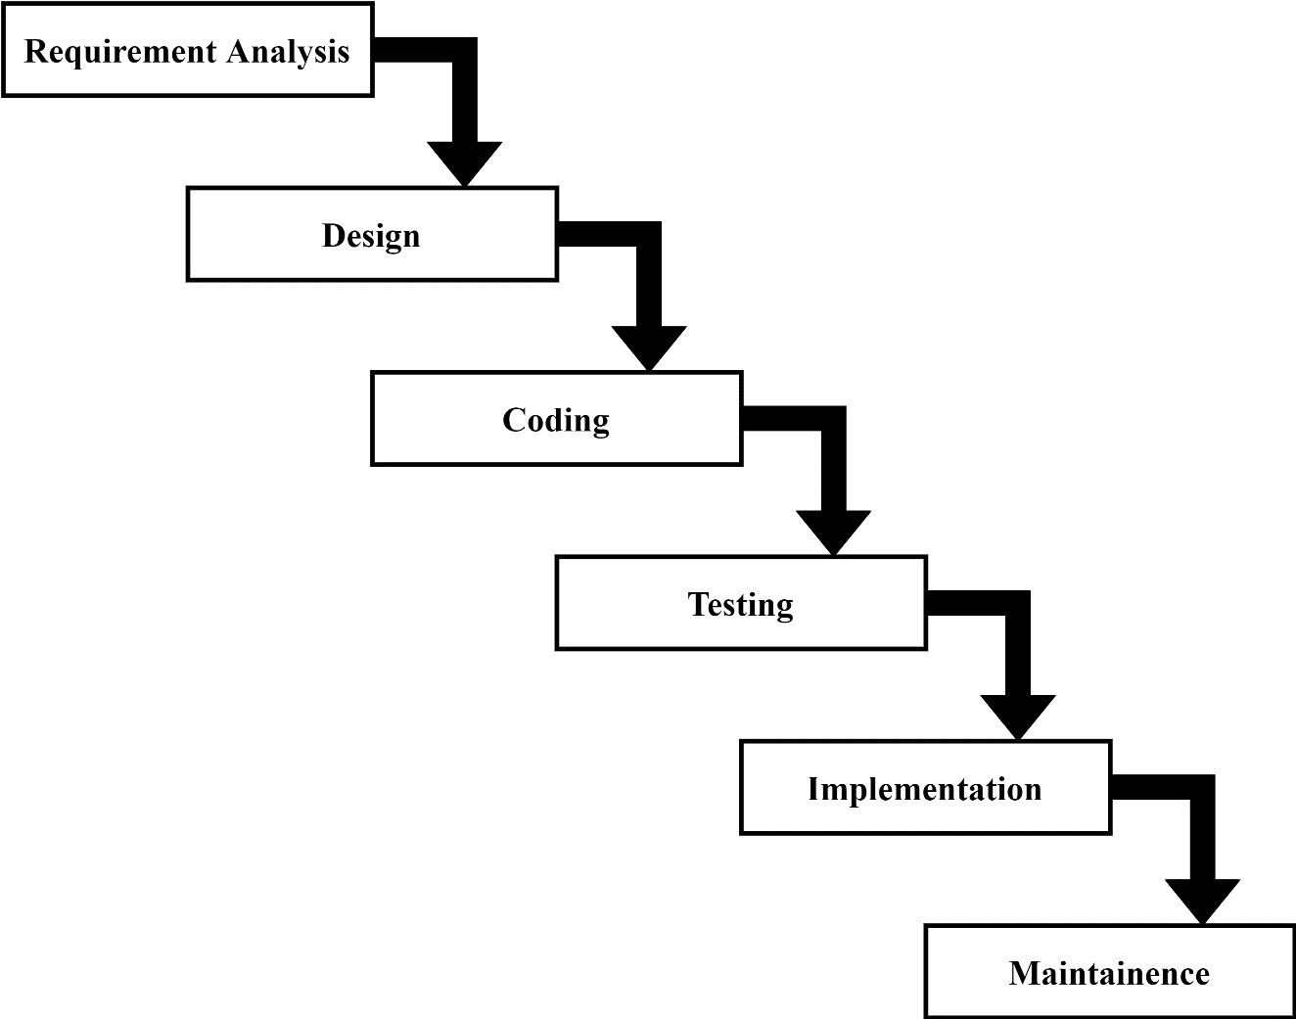high-quality software for the user’s expectation, reaches within times. We are going to use a waterfall model to build this project. It is also known as a linear-sequential lifecycle model. The Waterfall model is the earliest SDLC approach that was used for software development. In this model, each phase must be completed before the next phase can begin and there is no overlapping in the phases. For this project we have clear and fixed requirements, well-understood technology to build this project and this model is easy to understand so, we are using this model to build this project [2].

**Figure 3.1: Waterfall model**

### 3.1.1 Requirement Analysis

For any system, there are functional and non-functional requirements to be considered.

while determining the requirements of the system. Functional requirements are product features or functions those developers must implement to enable users to accomplish their tasks. And Non-functional Requirements (NFRs) define system attributes such as security, reliability, performance, maintainability, scalability, and usability.

Functional Requirements

* Authentication and Authorization:
* Only authenticated users, including admins and meter reader, should have access to the system.
* Admins and Meter reader must authenticate themselves before accessing system functionalities.
* Users must authenticate themselves before accessing their account features.

Admin Functionality:

Admins will have access to the following functionalities:

* Add, update, or delete water billing packages like bills,readings etc.
* Add meter reader for reading users water meter.
* View details of available water billing packages.
* Search for specific users billing packages.
* Add, manage, update, or delete users or meter reader accounts.
* Manage user accounts, including updating or deleting user profiles.

Meter Reader Functionality:

* Meter reader will have access to the following functionalities:
* Search for available users of water billing system.
* Update meter readings

Users Functionality:

* User will have access to the following functionalities:
* User can file complain and see status of complain and it’s details.
* View detailed information about water bills , including pricing rate , reading dates.
* Make online payments securely for water bills .
* User can see his/her payment records.

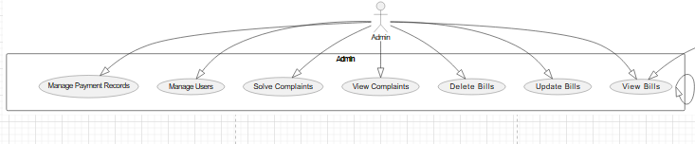

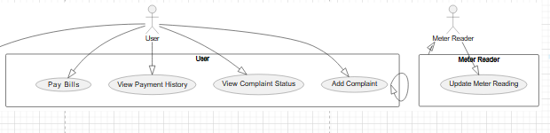

**Figure 3.2: Use case digram**

**II. Non-Functional Requirements**

**Security:** The system can only be accessed after login. Users can login with email and

password.

**Usability:** The system will be user-friendly. The UI should be simple enough for everyone

too.

**Accuracy:** The data stored about the Admin, Meter reader and user should be correct, consistent, and reliable.

**Availability:** The System should be available for the duration .The System operates and responds to the requests as soon as possible.

**Maintainability:** The software should be easily maintainable and adding new features and making changes to the software must be as simple as possible.

**Portability:** The software should function properly on multiple environments/devices.

### 3.1.2 Feasibility Analysis

A feasibility study is a detailed analysis that considers all the critical aspects of a proposed project to determine the likelihood of it succeeding. A feasibility analysis is used to determine the viability of an idea, such as ensuring a project is legally and technically feasible as well as economically justifiable. It tells us whether a project is worth the investment in some cases, a project may not be doable.

Feasibility studies undergo four major analyses to predict the system to be success and they

are as follows:

• Technical Feasibility

• Operational Feasibility • Economic Feasibility • Schedule Feasibility

**I. Technical Feasibility**

This study is carried out to check the technical requirements of the system. We can strongly

say that it is technically feasible, since there will not be much difficulty in getting required resources for the development and maintaining the system as well. All the resources needed for the development of the software are easily collected.

**II. Operational Feasibility**

The system is easy to operate with the basic knowledge of computation and internet. Well

trained manpower is not necessary. Users can easily access the system as it is user friendly in many aspects with good UI.

**III. Economic Feasibility**

Development of this application is highly economically feasible. The organization need not

must spend too much money for the development of the system. The only thing to be done is to make an environment for the development of the system in comfortable environment.

**IV. Schedule Feasibility**

The schedule feasibility shows the estimated time to complete the project. This includes the schedules of each process in a project and the total project time. This system that we developed is schedule feasible as it doesn’t require more time for the development phase. A Gantt chart is used for planning projects of all sizes, and it is a useful way of showing that work is scheduled to be done on a specific day. It can also help you to view the start and end dates of a project in one simple chart.

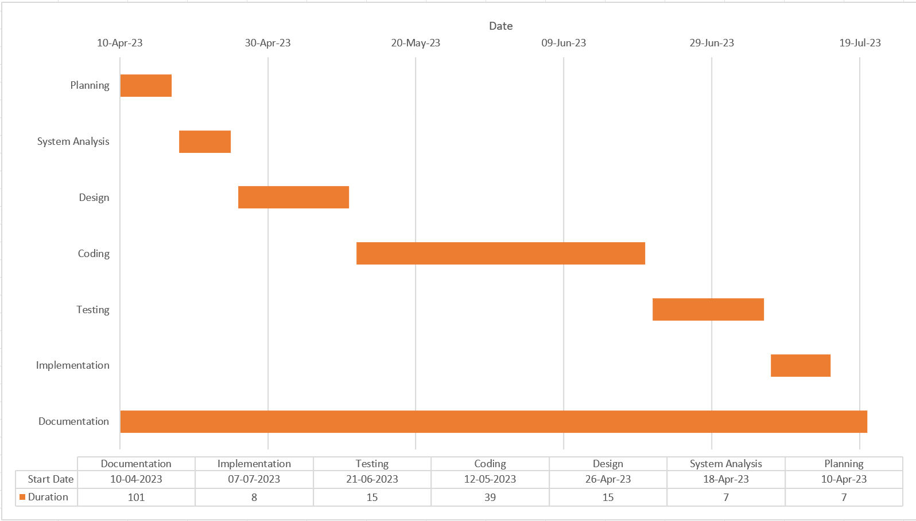

**Figure 3.3: Gantt chart**

### 3.1.3 Data Modelling (ER Diagram)

This ER (Entity Relationship) diagram represents the model of this project (Toursim

Management System).

**Figure 4: ER Diagram**

**Figure 3.4: ER Digram**

### 3.1.4 Process Modelling (DFD)

**Figure 3.5: Context Diagram**

Process modelling involves graphically representing the processes, or actions, that capture,

manipulate, store, and distribute data between a system and its environment and among components within a system. A common form of a process model is a data-flow diagram (DFD)**.** A data-flow diagram is a graphic that illustrates the movement of data between external entities and the processes and data stores within a system.

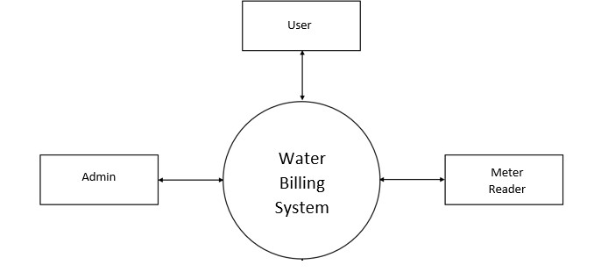

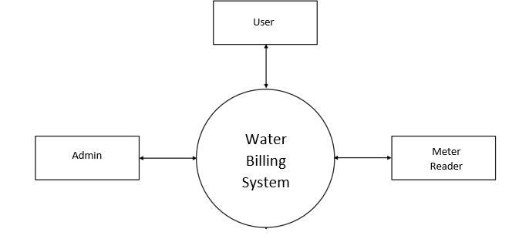





**Figure 3.6: Level 1 DFD**

­­

**Figure 3.7.1: Admin Level 2 DFD**

**Figure 3.7.2: Meter Reader Level 2 DFD**

1

**Figure 3.7.3: User Level 2 DFD**

## 3.2 System Design

System Design is the process of defining the elements of a system such as the architecture, modules and components, the different interfaces of the component and the data that goes through the system. System design gives the knowledge of the requirements and analysis to design the software product. It is meant to satisfy the needs and requirements of a business or organization through the engineering of a coherent and well-running system. In this chapter we will be dealing with the module, database design, user interface design and the program design. For the designing of the application, various diagrams like sequence diagram, activity diagram etc. have been used.

### 3.2.1 Architectural Design

An architectural diagram is a visual representation that maps out the physical

implementation for components of a software system.

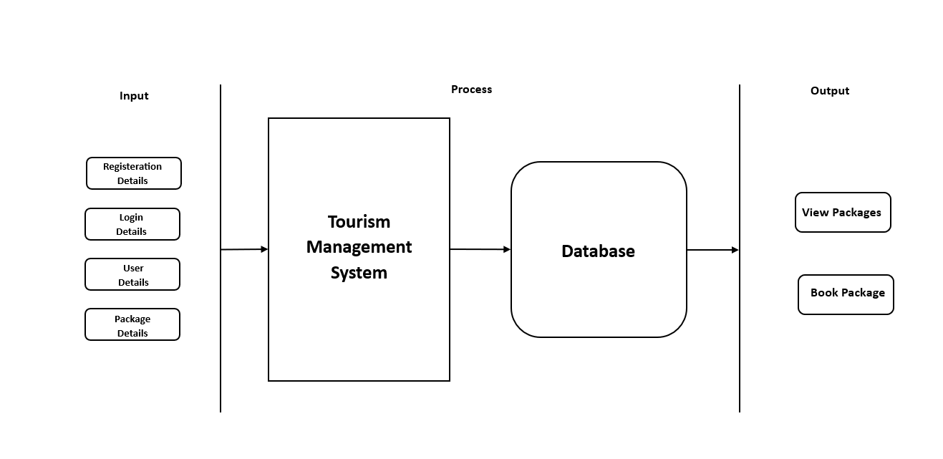

**Figure 3.8: Architectural Diagram**

**Water Billing System**

### 3.2.2 Database Schema Design

The design of the database is called schema. This tells us about the structural view of the database [3]. A database schema represents the logical configuration of all or part of a relational database. A database schema indicates how the entities that make up the database relate to one another, including tables, views, stored procedures, and more. Typically, a database designer creates a database schema to help programmers whose software will interact with the database.

**Figure 3.9: Database Schema**

### 3.2.3 Interface Design

Interface design is an important part of software development. User interface is the front-end application view to which user interacts to use the software. Users can manipulate and control the software as well as hardware by means of user interface. UI should be as simple as possible.

**Figure 3.10.1: Login Page Design**

**Figure 3.10.2: Admin home page design**

**Figure 3.10.3:Meter Reader home page design**

**Figure 3.10.4: User registration page design**

**Figure 3.10.6: Meter Reader detail page design**

**Figure 3.10.5: User detail page design**

**Figure 3.10.7: Bills view details page design**

**Figure 3.10.8: complain detail page design**

### 3.2.4 Software Design

**I. Sequence Diagram**

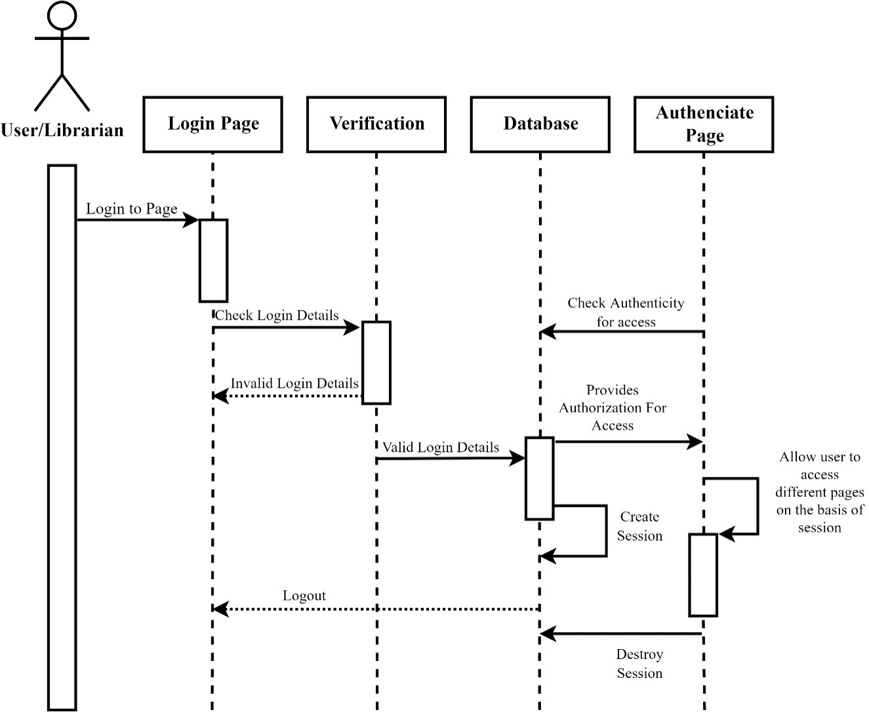

**Admin/Meter Reader/User**

**Tourist/Guide**

**Tourist/Guide**

**Tourist/Guide**

**Tourist/Guide**

**Tourist/Guide**

**Tourist/Guide**

**Tourist/Guide**

**Figure 3.11.1: Login sequence diagram**

**Figure 3.11.2: Admin sequence diagram**

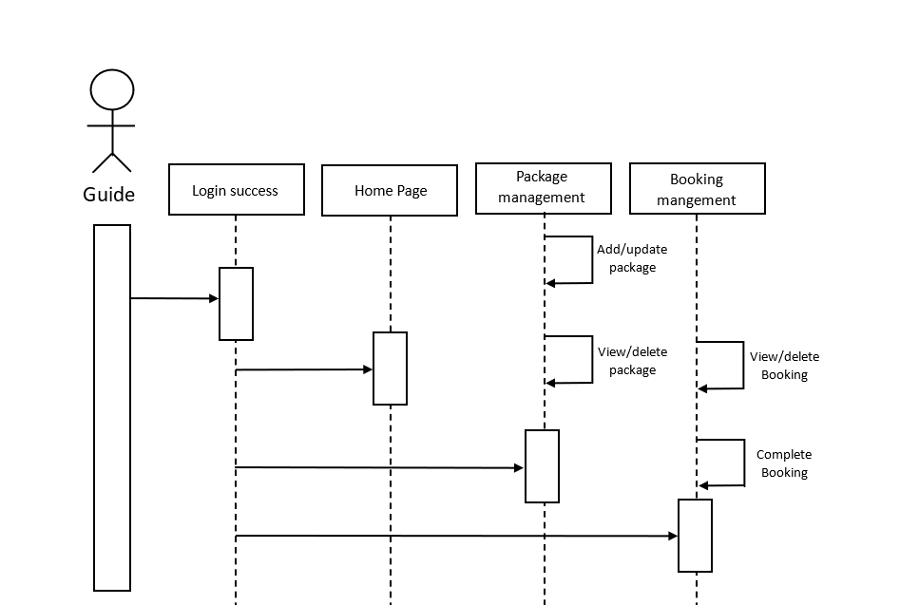

**Figure 3.11.3: Meter Reader sequence diagram**

Meter

Reader

Reading  
management

Update Reading

**Figure 3.11.4: User sequence diagram**

**II. Activity Diagram**

Activity diagrams are graphical representations of workflows of stepwise activities and

actionswith support for choice, iteration, and concurrency. Activity diagram is basically a flowchart to represent the flow from one activity to another activity. The activity can be described as an operation of the system.

**Figure 3.12: Activity diagram**

# Chapter 4: Implementation and Testing

**4.1 Implementation**

**4.1.1 Tools Used**

In the development of the Water Billing Management System (wbill), a combination of frontend and backend technologies has been utilized to ensure a robust and efficient application.

**Frontend**

* **HTML, CSS, and JavaScript (JS):**

HTML, CSS, and JavaScript have been employed to implement the frontend of the wbill system. HTML provides the structure of web pages, while CSS is used for styling and layout, and JavaScript enhances interactivity and user experience.

**Backend and Database**

* **PHP and MySQL:**

The backend of wbill is implemented using PHP, a server-side scripting language, while MySQL database is utilized for storing and managing data. PHP facilitates dynamic content generation and server-side processing, while MySQL ensures efficient data storage and retrieval.

**4.1.2** **Implementation Details of Modules**

To build a modern and efficient web application like wbill, the following technologies have been utilized:

* **HTML, CSS, and JavaScript (Frontend):**

HTML provides the structural foundation of web pages, while CSS enhances the visual appearance and layout. JavaScript adds interactivity and dynamic behavior to the frontend, making the user experience more engaging and responsive.

* **PHP (Backend):**

PHP serves as the backend scripting language, handling server-side logic and processing for waterbillingSystem . It interacts with the frontend to manage user authentication, data processing, and communication with the MySQL database.

* **MySQL (Database):**

MySQL is employed as the relational database management system (RDBMS) for wbill, ensuring secure and efficient storage, retrieval, and management of data related to user accounts, billing information, and system configurations.

Various software tools have been utilized throughout the development process, including:

* **Microsoft Word:** For documentation purposes.
* **Visual Studio Code:** As an integrated development environment (IDE) for coding.
* **Google Meet:** For communication and collaboration among team members.
* **Diagrams.net:** For creating diagrams and visual representations of system architecture and workflow.

**4.2 Testing**

Software testing is an essential aspect of ensuring the functionality, correctness, and quality of the Water Billing Management System (wbill). It involves an empirical technical investigation aimed at identifying and rectifying errors and anomalies within the software. Through rigorous testing processes, stakeholders can gain confidence in the reliability and effectiveness of the wbill system. Testing encompasses various methodologies and techniques to validate the system's behavior and performance within its intended operational context, ultimately ensuring a seamless and robust user experience.

**White box Testing**

White-box testing is detailed investigation of internal logic and structure of the code.

White-box testing is also called glass testing or open-box testing. To perform white box testing on an application, a tester needs to know the internal working of the code.

**Black box Testing**

The technique of testing without having any knowledge of the interior workings of the

application is called black-box testing. The tester is oblivious to the system architecture and does not have access to the source code. Typically, while performing a black-box test, a tester will interact with the system’s user interface by providing inputs and examining outputs without knowing how and where the inputs are worked upon.

### 4.2.1 Test Cases for Unit Testing

Unit testing is a software development process in which the smallest testable parts of an

applications, called units, are individually and independently scrutinized for proper operation. This testing methodology is done during the development process by the software developers and sometimes QA staff. The main objective of unit testing is to isolate written code to test and determine if it works as intended.

Unit testing is an important step in the development process, because if done correctly, it can help detect early flaws in code which may be more difficult to find in later testing stages.

**Test Cases Table 4.1:**

|  |  |  |  |  |  |  |
| --- | --- | --- | --- | --- | --- | --- |
| **TC ID** | **Test Case** | **Test Data** | **Description** | **Expected result** | **Actual Result** | **Remark** |
| 1 | Testing Admin Login | Email:  [admin@gmail.com](mailto:admin@gmail.com)  Password:  admin123 | While entering correct credentials | Sucessfully logged in and redirecr to admin home page | As expected, result | Pass |
| 2 | Testing Admin login | Email:  [admin@gmail.com](mailto:admin@gmail.com)  Password:  adminyyy | While entering incorrect credentials | Show error:  Incorrect email or password | As expected, result | Pass |

|  |  |  |  |  |  |  |
| --- | --- | --- | --- | --- | --- | --- |
| **TC ID** | **Test Case** | **Test Data** | **Description** | **Expected result** | **Actual Result** | **Remark** |
| 3 | Testing User Login | Email:  [test@gmail.com](mailto:test@gmail.com)  Password:  123456 | While entering correct credentials | Sucessfully logged in and redirecr to guide home page | As expected, result | Pass |
| 4 | Testing User login | Email:  [test@gmail.com](mailto:test@gmail.com)  Password:  itututu123 | While entering incorrect credentials | Show error:  Incorrect email or password | As expected, result | Pass |
| 5 | Testing  Meter  Reader Login | Email:  [test1@gmail.com](mailto:test1@gmail.com)  Password:  123456 | While entering correct credentials | Sucessfully logged in and redirecr to guide home page | As expected, result | Pass |
| 6 | Testing  Tourist Login | Email:  [test1@gmail.com](mailto:test1@gmail.com)  Password:  my123456 | While entering incorrect credentials | Show error:  Incorrect email or password | As expected, result | Pass |
| 7 | On clicking logout button | Click Logout button | Clicking logout button | Redirect to home page | As expected, result | Pass |
| 8 | Adding Meter Reader by admin | All required data to create guide | Entering all required guide details | Show message Meter Reader added successfully | As expected, result | Pass |
| 9 | Adding new Readings by Meter reader | All required data to update and create readings | Entering all required  details | Show message  readings update successfully | As expected, result | Pass |

### 4.2.1 Test Cases for System Testing

System Testing includes testing of a fully integrated software system. System testing is

testing conducted on a complete integrated system to evaluate the system's compliance with its specified requirements. All the modules/components are linked together to see whether the system performs as planned. This is crucial for producing high-quality output.

**Test Cases Table 4.2:**

|  |  |  |  |  |  |  |
| --- | --- | --- | --- | --- | --- | --- |
| **TC ID** | **Test Case** | **Test Data** | **Description** | **Expected result** | **Actual Result** | **Remark** |

# Chapter 5: Conclusion and Future work

## Lesson Learnt / Outcome:

The development of the Water Billing Management System (wbill) has provided valuable insights and outcomes for improving water billing processes:

**Lessons Learned:**

**The importance of digitizing traditional systems:** Developing wbill highlighted the significance of transitioning from manual to digital processes, enabling more efficient and convenient management of water billing data.

**User-centric design:** Understanding the needs and preferences of users, including administrators and tourists, is crucial for creating a user-friendly and effective system.

**Utilizing appropriate technologies:** Selecting suitable frontend and backend technologies, such as HTML, CSS, JavaScript, PHP, and MySQL, is essential for ensuring the functionality and performance of the system.

## 5.2 Conclusion

The Water Billing Management System (wbill) presents a modern and efficient solution for managing water billing processes. By providing a digitalized platform, wbill offers numerous benefits to administrators and users:

**Improved efficiency:** wbill streamlines water billing processes, saving time and effort for administrators and users.

**Enhanced user experience:** The user-friendly interface of wbill ensures a seamless and convenient experience for both administrators and tourists.

**Greater accuracy:** Digitizing water billing data minimizes errors and enhances the accuracy of billing information and transactions.

## 5.3 Future Recommendations

For future enhancements of the Water Billing Management System (wbill), the following recommendations are proposed:

Integration of QR code-based functionality: Implementing a QR code-based system for water bill issue and payment can further enhance the efficiency and convenience of transactions.

Introduction of reservation feature: Adding a feature for users to reserve water billing packages or schedule appointments for meter readings can improve user experience and accessibility.

# References

|  |  |
| --- | --- |
| [2] | "tutorialspoint.com," 6 9 2006. [Online]. Available: https://www.tutorialspoint.com/sdlc/sdlc_waterfall_model.htm. [Accessed 3 5 2023]. |
| [3] | "wikipedia," 15 1 2001. [Online]. Available: https://en.wikipedia.org/wiki/Database_schema. [Accessed 1 6 2023]. |
| [5] | "Google," 4 9 1998. [Online]. Available: https://www.google.com. [Accessed 10 4 2023]. |

# Appendices